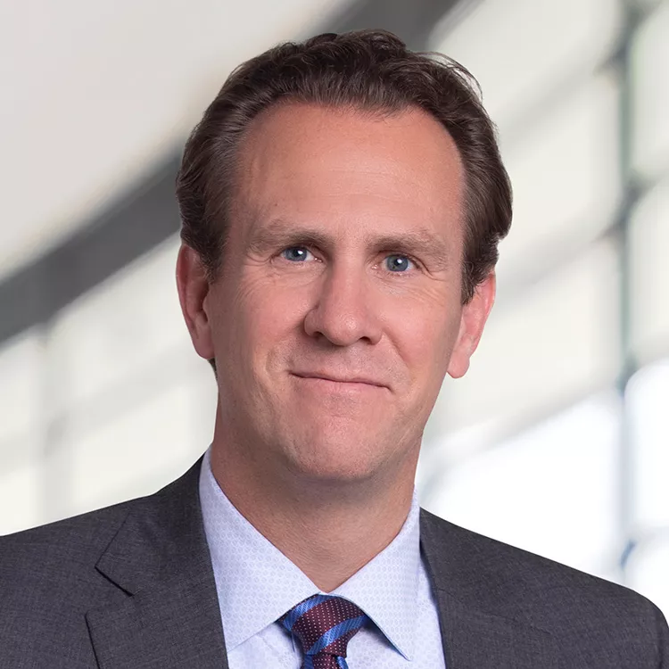

Brett Lininger, Esquire
Lobbyist
Brett has developed a reputation as a hard-working and connected lobbyist who delivers results for his clients. He is known for being very well prepared and having a deep subject matter expertise of the issues, no matter the complexity.

Over the years, Brett has successfully represented clients in a wide array of matters including insurance (all lines), healthcare, energy, information technology, automotive manufacturing, budget, and gaming.

Some of the clients he has represented include AFLAC, MetLife, Independent Insurance Agents of Maryland, Kaiser Permanente, Liberty Mutual, NRG, Brookfield Renewable, The National Football League, Easton Utility Commission, Health Distribution Alliance, The Cigar Association of America, Hertz Rental Car, and U.S. Travel Insurance Association.

As a native of Maryland, Brett maintains strong relationships with key decision makers at the state, county, and local levels from both sides of the aisle. Prior to joining Kress Hammen Government Affairs, Brett served as the Director of Government Affairs at the Maryland Insurance Administration during the Ehrlich Administration. He then started his own government affairs consulting firm before joining a major law firm where he became partner and Chair of the Business Practice Group with his practice focusing on government affairs and insurance regulatory matters. He then joined a corporate boutique firm and its government affairs entity.

Brett graduated cum laude from the University of Baltimore School of Law, and currently resides in Baltimore County.

