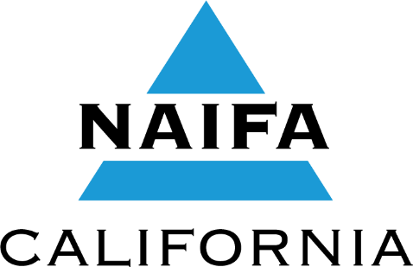
National Association of Insurance and Financial Advisors-California
Norman G. Levine
Distinguished Service Award 2022
Purpose & Presentation
“To recognize individuals who have given meritorious service to
the insurance and financial services industry, and
the community in ways that enhance the image of the agent/advisor.
These individuals will have clearly demonstrated the attributes of personal success.”
Norman G. Levine Distinguished Service Award 2022

This award is presented at the NAIFA-California Norman G. Levine
Distinguished Service Awards Banquet held during the
NAIFA-California Career Advancement Conference.
Criteria for Selection
The following criteria are considered in selecting the award recipient:
- Evidence of meritorious service to the insurance and financial advisors association and/or the life and health insurance industry and/or the community.
- A current member of a local insurance and financial advisors association in California, and/or a person dedicated to the enhancement of the association/industry.
- If the candidate is a Past President of NAIFA-California, three years must have lapsed since the individual held the office of state President.
- Current NAIFA-California Board of Trustees members are not eligible for the award.
- Prior service on the NAIFA-California Board of Trustees as an officer is not required.
Selection Committee
Nominations are reviewed and the award recipient determined by a committee consisting of the three most recent NAIFA-California Past Presidents not eligible for the award and the past three prior recipients of the award.
Submission of Nomination & Supporting Information
Nominations are to be submitted by an individual member on behalf of another individual.
Deadline for submission of nomination is July 21, 2022.
Nominations must be received at NAIFA-California no later than July 21, 2022;
postmarks will not be accepted. The Nomination must be received by deadline date. Only nominations submitted using this application will be accepted.
When submitting a nomination, please prepare a detailed and organized presentation.
Do not submit in binder format, submissions provided in binder format will not be accepted.
DO NOT assume the Selection Committee will know your nominee.
Describe in specific detail the qualifications and contributions of your candidate which,
in your opinion, fulfill the stated purpose of this award.
Outside documentation, such as newspaper clippings or magazine articles are always helpful.
Please label explanations and all supporting outside documentation with the section letter it pertains to. For EXAMPLE, explanation and supporting documentation for question B should be labeled “B”.
Nominations are kept on file for three years and will be reconsidered each of those years.
NAIFA-California will notify each nominator when their candidate’s nomination is about to expire
and will provide the nominator an opportunity to reapply.
Nominee Please TYPE all information requested.

^{NOMINEE NAME}

^{COMPANY}

^{ADDRESS}

^{CITY/ZIP}

^{EMAIL} ^{Cell Phone} ^{Business Phone}

Name of Nominator Please TYPE all information requested.
I have prepared and labeled all supporting documents provided in this application and consider it accurate and complete to the best of my knowledge.

^{YOUR NAME} ^{Local Association}

^{COMPANY}

^{ADDRESS} ^{CITY/ZIP}

^{PHONE} ^{FAX}

^{EMAIL} ^{Cell Phone} ^{Business Phone}
A. Explain how this individual has given meritorious service to the NAIFA ASSOCIATION (local, affiliate, state and/or national) in ways that enhance the image of the advisor.
Attach additional sheets if necessary.
Examples of information which may be included are listed below.
You are not limited to this list. This is provided merely to assist you. Please TYPE all information requested.
- Organizational positions held (committee chairperson, Vice President, President, etc.)
- Designations/educational degrees received
- Significant accomplishments attained by these organizations as a result of this person's involvement
- Honors received from the insurance and financial advisors associations
- Financial contributions given to the association (PAC, Prospector Fund, or scholarship funds, etc.)
- Current involvement
- Political involvement on the Local, State, National levels
B. Explain how this individual has given meritorious service to the insurance and financial advisors INDUSTRY in ways that enhance the image of the advisor. Attach additional sheets if necessary.
Examples of information which may be included are listed below.
You are not limited to this list. This is provided merely to assist you. Please TYPE all information requested.
- Present and past business affiliations and accomplishments
- Organizational positions held in allied groups such as MDRT, SFSP, Estate Planning Councils, Gold Key, and so forth (Committee Chairperson, Vice President, President, etc.)
- Designations/educational degrees received
(i.e. CLU, ChFC, LUTCF, RHU, FLMI, MFS, CPCU, CFP, CEBS, RFC, FSS, CAE, REBC, CAP, CASL etc.)
- Honors received from the industry
- News clippings publicizing the individual's achievements
- Recognition received for attaining significant production levels: (i.e. MDRT, Court of the Table, Top of the Table, NSAA, NQA, Company Honors, National Management Award, Career Development Award, Knights of the Round Table, etc.)
C. Explain how this individual has given meritorious service to the COMMUNITY in ways that enhance the image of the advisor. Attach additional sheets if necessary.
Examples of information which may be included are listed below.
You are not limited to this list. This is provided merely to assist you. Please TYPE all information requested.
- Involvement in religious organizations or service clubs
- Service to charitable organizations
- Election to public office
- News clippings publicizing the individual's involvement
- Involvement with youth or educational organizations
- Involvement with athletic organizations
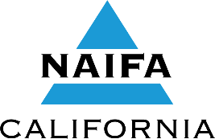

Applications with all labeled supporting documents must be received at NAIFA-California
No later than July 21, 2022
NO POSTMARKS WILL BE ACCEPTED
Send completed application with labeled supporting documents to:
NAIFA-California • 600 State Street, Suite A • Cedar Falls, IA 50613 •
Fax: 703-770-8224 • E-Mail: info@naifacalifornia.org

