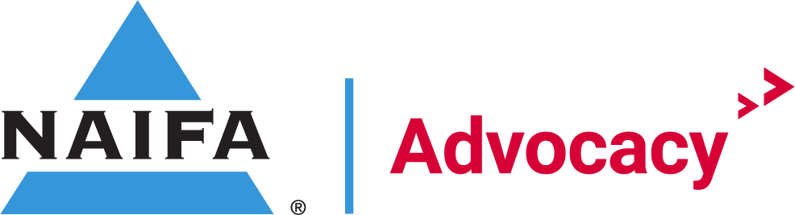

April Regional Grassroots Committee Meeting Agenda

Agenda

Welcome Holt/Josh O’Gara

IFAPAC Stephanie Sheridan

State Legislature Update Bianca Alonso Weiss

Federal Relationship Recap Holt
April 2023 Total Gaps
- House Gaps – 129
- Senate Gaps – 10
  - 139 total gaps
- House Coverage Percentage – 71%
- Senate Coverage Percentage – 90%
  - 75% Federal Coverage

Key House Committee Gaps
  - Ways & Means
    - 4 Gaps:
      - MN CD7- Michelle Fischbach
      - NY CD24- Claudia Tenney
      - PA CD3- Dwight Evans
      - PA CD11- Lloyd Smucker
  - Financial Services
    - 14 Gaps
      - CO CD7- Brittany Petterson
      - GA CD5- Nikema Williams
      - IL CD6- Sean Casten
      - MA CD7- Ayanna Pressley
      - MI CD12- Rashida Tlaib
      - NV CD4- Steven Horsford
      - NY CD5- Gregory Meeks
      - NY CD7- Nydia Velazquez
      - NY CD15- Ritchie Torres
      - NY CD17- Michael Lawler
      - NC CD13- Wiley Nickel
      - TX CD17- Pete Sessions
      - TX CD29- Sylvia Garcia

- Total percentage of US House Districts with a relationship:
  - January 2023: 62%
  - February 2023:67%
  - March 2023: 68%
  - April 2023: 71%
- Total number of US House Gaps:
  - January 2023: 166
  - February 2023: 146
  - March 2023: 140
  - April 2023: 129
- Total number of States without US House Gaps:
  - January 2023: 7
  - February 2023: 12
  - March 2023: 14
  - April 2023: 16
- Total number of States with US House Gaps:
  - January 2023: 43
  - February 2023: 38
  - March 2023: 36
  - April 2023: 34

State | Total US House Gaps | State | Total US House Gaps
Alabama | 3 | Nebraska | 0
Alaska | 1 | Nevada | 2
Arizona | 0 | New Hampshire | 0
Arkansas | 0 | New Jersey | 3
California | 11 | New Mexico | 2
Colorado | 5 | New York | 18
Connecticut | 1 | North Carolina | 4
Delaware | 0 | North Dakota | 0
Florida | 9 | Ohio | 2
Georgia | 4 | Oklahoma | 0
Hawaii | 1 | Oregon | 3
Illinois | 9 | Pennsylvania | 7
Indiana | 0 | Rhode Island | 1
Iowa | 0 | South Carolina | 2
Kansas | 2 | South Dakota | 0
Kentucky | 2 | Tennessee | 1
Louisiana | 4 | Texas | 9
Maine | 0 | Utah | 0
Maryland | 4 | Vermont | 1
Massachusetts | 3 | Virginia | 5
Michigan | 1 | Washington | 3
Minnesota | 3 | West Virginia | 0
Mississippi | 0 | Wisconsin | 0
Missouri | 1 | Wyoming | 1
Montana | 1 | Idaho | 0
Key Senate Committee Gaps
  - Finance
    - 2 Gaps
      - Sen. Sheldon Whitehouse, RI
      - Sen. Maggie Hassan, NH
  - Banking
    - 4 Gaps
      - Sen. Tina Smith, MN
      - Sen. Raphael Warnock, GA
      - Sen. Jon Kennedy, LA
      - Sen. Katie Britt, AL,

- Total percentage of US Senate Seats with a relationship: 90%
- Total number of US Senate Gaps: 10
- Total number of States without US Senate Gap: 42
- Total number of States with US Senate Gap: 8

State | Total Senate Gaps | State | Total Senate Gaps
Alabama | 2 | Nebraska | 0
Alaska | 0 | Nevada | 0
Arizona | 0 | New Hampshire | 1
Arkansas | 0 | New Jersey | 0
California | 0 | New Mexico | 0
Colorado | 0 | New York | 0
Connecticut | 0 | North Carolina | 0
Delaware | 0 | North Dakota | 0
Florida | 0 | Ohio | 0
Georgia | 2 | Oklahoma | 1
Hawaii | 0 | Oregon | 0
Illinois | 0 | Pennsylvania | 0
Indiana | 0 | Rhode Island | 1
Iowa | 0 | South Carolina | 0
Kansas | 0 | South Dakota | 0
Kentucky | 0 | Tennessee | 0
Louisiana | 1 | Texas | 0
Maine | 0 | Utah | 0
Maryland | 0 | Vermont | 0
Massachusetts | 0 | Virginia | 0
Michigan | 0 | Washington | 0
Minnesota | 1 | West Virginia | 0
Mississippi | 0 | Wisconsin | 0
Missouri | 1 | Wyoming | 0
Montana | 0 | Idaho | 0

Grassroots Training Course Josh O’Gara
- Financial Security Advocate Academy Update
  - Courses Completed by Grassroots Committee
- April Class currently accepting- closes 4.14.
- Congressional Conference Class
  - Each regional member will be given a list of their respective states and attendees
  - Let’s encourage all to complete the FSAA prior to getting to Congressional Conference
- https://academy.congressfoundation.org/pages/27/naifa-home

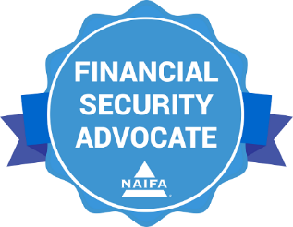

August In-District Holt
- August In-District Challenge
- ConCon attendee lists will be distributed to Regional Chairs
  - 1st timers
  - Key Gaps
    - Set up secondary meetings in-district

Year Focus Holt
- Quarter 2
  - Congressional Conference Recruitment
  - Grassroots Chapter Chair CAO Training
  - Promote FSA Training course for Congressional Conference
- Quarter 3
  - In-District Meetings
  - Promote FSA Training course
  - Recruit NAIFA members to participate in advocacy
- Quarter 4
  - Promote GOTV (VA, NJ, MI, LA)
  - Promote FSA Training Course

Next Meetings
Congressional Conference All-Attendee Webinars & State Caucus
- May 9th, 3pm Eastern Region
- May 10th, 3pm Western Region
- May 11th, 3pm Central Region

Reminders

Cook Catch Up sign up

Signature Events

Advocate: Congressional Conference
Congressional Conference is the annual fly-in to Washington, D.C. The event includes sessions with current legislators, updates from NAIFA Government Relations. and key insights from policy analysts. The event also entails pre-arranged meetings for members with their legislators.
Dates: May 22-23, 2022
Location: JW Marriott in Washington DC
Register: https://conference.naifa.org/2023

Quick Links:
- Log Relationships
  - www.naifa.org/advocate
- FSAA Sign Up
  - https://members.naifa.org/fsa
- FSAA Website
  - https://academy.congressfoundation.org/pages/27/naifa-home
- Congressional Conference Registration
  - https://conference.naifa.org/2023

