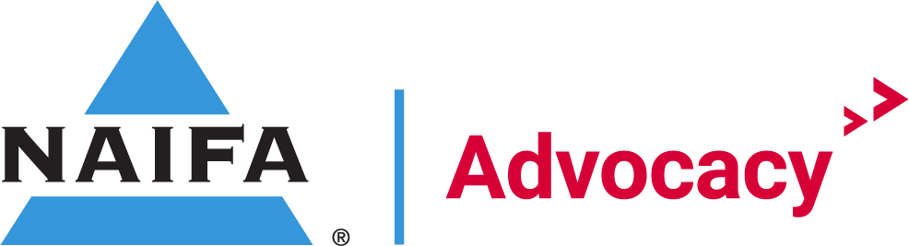

January Regional Grassroots Meeting Agenda
1/24/2023
3:00pm to 4:00pm

Agenda

Welcome Remarks Andrew Holt

State Legislature Update Bianca Alonso Weiss

Grassroots Updates Andrew Holt
- Regional Chairs (West, East, Central)
- US House Relationship Gaps
Total percentage of US House Districts with a relationship: 62%
Total number of US House Gaps: 166
Total number of States without US House Gaps: 7
Total number of States with US House Gaps: 43
State | Total US House Gaps | State | Total US House Gaps
Alabama | 3 | Nebraska | 1
Alaska | 1 | Nevada | 2
Arizona | 3 | New Hampshire | 0
Arkansas | 0 | New Jersey | 4
California | 11 | New Mexico | 2
Colorado | 5 | New York | 20
Connecticut | 1 | North Carolina | 3
Delaware | 1 | North Dakota | 0
Florida | 10 | Ohio | 7
Georgia | 4 | Oklahoma | 1
Hawaii | 1 | Oregon | 4
Illinois | 9 | Pennsylvania | 8
Indiana | 4 | Rhode Island | 1
Iowa | 3 | South Carolina | 3
Kansas | 3 | South Dakota | 0
Kentucky | 3 | Tennessee | 1
Louisiana | 4 | Texas | 9
Maine | 0 | Utah | 2
Maryland | 4 | Vermont | 1
Massachusetts | 3 | Virginia | 5
Michigan | 6 | Washington | 4
Minnesota | 4 | West Virginia | 0
Mississippi | 1 | Wisconsin | 1
Missouri | 1 | Wyoming | 1
Montana | 1 | Idaho | 0

Advocacy Action Center Andrew Holt
- Log Relationships
  - www.naifa.org/advocate
- Pull district rosters
  - Federal and State
NAIFA APP Andrew & Bianca
- State Day on the Hill
  - https://advocacy.naifa.org/statelegislativedays
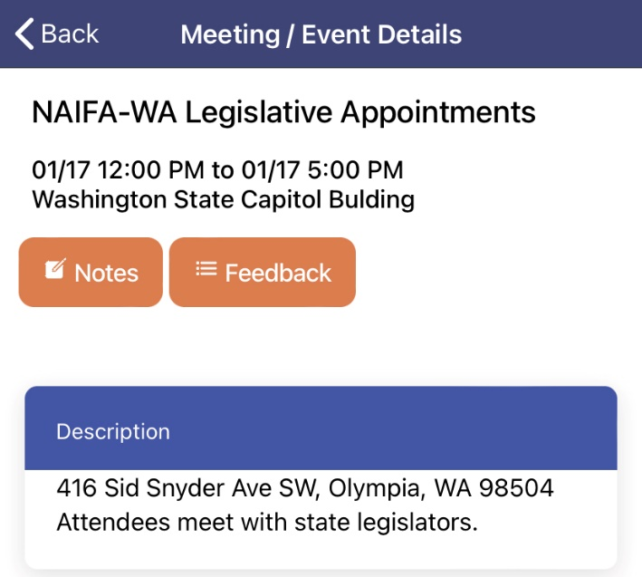
- Reporting/tracking relationships at the state level

Grassroots Training Course Andrew Holt
- New Financial Security Advocate Academy launching soon

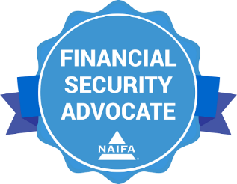

Next Meetings
Western Regional Chair Meeting: February 21st, 2023 at 3pm EST
Eastern Regional Chair Meeting: February 22nd, 2023 at 10am EST
Central Regional Chair Meeting: February 23rd, 2023 at 11am

Reminders
Cook Catch Up sign up

Signature Events
Advocate:
Congressional Conference
Congressional Conference is the annual fly-in to Washington, D.C. The event includes sessions with current legislators, updates from NAIFA Government Relations. and key insights from policy analysts. The event also entails pre-arranged meetings for members with their legislators.
Dates: May 22-23, 2022
Location: JW Marriott in Washington DC
Register: https://conference.naifa.org/2023

