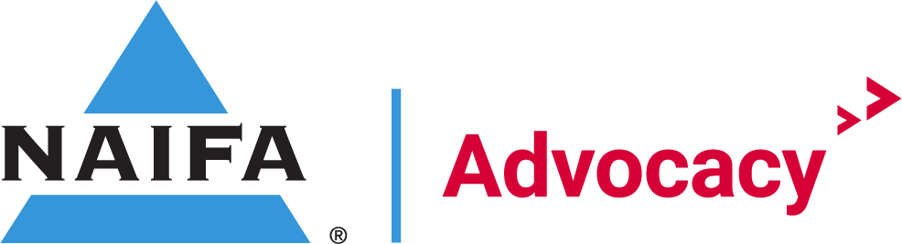

March National Grassroots Regional Meeting Agenda

Agenda

National Grassroots Chairman Welcome Josh O’Gara

IFAPAC Sheridan

Federal Relationship Recap Holt
March 2023 Total Gaps
- House Gaps – 140
- Senate Gaps – 15
  - 155 total gaps
- House Coverage Percentage – 68%
- Senate Coverage Percentage – 85%
  - 73% Federal Coverage

Key House Committee Gaps
  - Ways & Means
    - 4 Gaps:
      - MN CD7- Michelle Fischbach
      - NY CD24- Claudia Tenney
      - PA CD3- Dwight Evans
      - PA CD11- Lloyd Smucker
  - Financial Services
    - 14 Gaps
      - CO CD7- Brittany Petterson
      - GA CD5- Nikema Williams
      - IL CD6- Sean Casten
      - MA CD7- Ayanna Pressley
      - MI CD12- Rashida Tlaib
      - NV CD4- Steven Horsford
      - NY CD5- Gregory Meeks
      - NY CD7- Nydia Velazquez
      - NY CD15- Ritchie Torres
      - NY CD17- Michael Lawler
      - NC CD13- Wiley Nickel
      - TX CD17- Pete Sessions
      - TX CD29- Sylvia Garcia

- Total percentage of US House Districts with a relationship:
  - January 2023: 62%
  - February 2023:67%
  - March 2023: 68%
- Total number of US House Gaps:
  - January 2023: 166
  - February 2023: 146
  - March 2023: 140
- Total number of States without US House Gaps:
  - January 2023: 7
  - February 2023: 12
  - March 2023: 14
- Total number of States with US House Gaps:
  - January 2023: 43
  - February 2023: 38
  - March 2023: 36

State | Total US House Gaps | State | Total US House Gaps
Alabama | 3 | Nebraska | 0
Alaska | 1 | Nevada | 2
Arizona | 0 | New Hampshire | 0
Arkansas | 0 | New Jersey | 3
California | 11 | New Mexico | 2
Colorado | 5 | New York | 19
Connecticut | 1 | North Carolina | 4
Delaware | 1 | North Dakota | 0
Florida | 10 | Ohio | 2
Georgia | 4 | Oklahoma | 0
Hawaii | 1 | Oregon | 3
Illinois | 9 | Pennsylvania | 8
Indiana | 0 | Rhode Island | 1
Iowa | 1 | South Carolina | 2
Kansas | 3 | South Dakota | 0
Kentucky | 2 | Tennessee | 1
Louisiana | 4 | Texas | 9
Maine | 0 | Utah | 0
Maryland | 4 | Vermont | 1
Massachusetts | 3 | Virginia | 5
Michigan | 4 | Washington | 4
Minnesota | 4 | West Virginia | 0
Mississippi | 0 | Wisconsin | 0
Missouri | 1 | Wyoming | 1
Montana | 1 | Idaho | 0

Key Senate Committee Gaps
  - Finance
    - 2 Gaps
      - Sen. Sheldon Whitehouse, RI
      - Sen. Maggie Hassan, NH
  - Banking
    - 5 Gaps
      - Sen. Tina Smith, MN
      - Sen. Raphael Warnock, GA
      - Sen. Jon Kennedy, LA
      - Sen. Katie Britt, AL,
      - Sen. John Fetterman, PA

- Total percentage of US Senate Seats with a relationship: 85%
- Total number of US Senate Gaps: 15
- Total number of States without US Senate Gap: 37
- Total number of States with US Senate Gap: 13

State | Total Senate Gaps | State | Total Senate Gaps
Alabama | 2 | Nebraska | 0
Alaska | 0 | Nevada | 1
Arizona | 0 | New Hampshire | 1
Arkansas | 0 | New Jersey | 0
California | 0 | New Mexico | 0
Colorado | 1 | New York | 0
Connecticut | 0 | North Carolina | 0
Delaware | 0 | North Dakota | 0
Florida | 0 | Ohio | 0
Georgia | 2 | Oklahoma | 1
Hawaii | 0 | Oregon | 0
Illinois | 1 | Pennsylvania | 1
Indiana | 0 | Rhode Island | 1
Iowa | 0 | South Carolina | 0
Kansas | 1 | South Dakota | 0
Kentucky | 0 | Tennessee | 0
Louisiana | 1 | Texas | 0
Maine | 0 | Utah | 0
Maryland | 0 | Vermont | 0
Massachusetts | 0 | Virginia | 0
Michigan | 0 | Washington | 0
Minnesota | 1 | West Virginia | 0
Mississippi | 0 | Wisconsin | 0
Missouri | 1 | Wyoming | 0
Montana | 0 | Idaho | 0

Congressional Conference CAO Holt
- Request went out last Friday for each state to ID a CAO for Congressional Conference
- Roles:
  - Facilitating introductions (virtually or in-person at fly-in events) between members of their state attending the same meetings.
  - Coaching new NAIFA members or members new to advocacy on best practices for representing themselves and their clients before elected officials.
  - Assigning members to moderate/lead meetings with elected officials, with particular emphasis on assigning leads comfortable spotlighting new or inexperienced advocates so that they may develop relationships with their representatives.
  - Ensuring that all members attending meetings on the Hill have read and understood the talking points and issue briefs provided by NAIFA Government Relations.
  - Providing feedback to NAIFA staff on meetings and fly-ins, generally.

States without a CAO assigned:

State | State
Arkansas | New Hampshire
Arizona | New Jersey
California | New Mexico
Hawaii | Nevada
Iowa
Idaho | South Dakota
 | Tennessee
Kansas | Virginia
Louisiana | Vermont
Massachusetts | Washington
Maine | Wyoming
Michigan
Minnesota
Missouri

Grassroots Training Course Holt
- Financial Security Advocate Academy Update
  - Courses Completed by Grassroots Committee
- https://academy.congressfoundation.org/pages/27/naifa-home
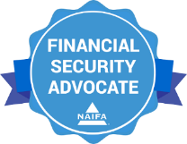

Year Focus Holt
- Quarter 1
  - Promote App for state days at the Capitol
    - Reporting Relationship, State Action Alert etc.
  - National Committee completes new FSA course hosted by CMF
  - Participation in State Day on the Hill efforts
- Quarter 2
  - Congressional Conference Recruitment
  - Grassroots Chapter Chair CAO Training
  - Promote FSA Training course for Congressional Conference
- Quarter 3
  - In-District Meetings
  - Promote FSA Training course
  - Recruit NAIFA members to participate in advocacy
- Quarter 4
  - Promote GOTV (VA, NJ, MI, LA)
  - Promote FSA Training Course

Next Meetings
Western Regional Chair Meeting: March 21st, 2023 at 3pm EST
Eastern Regional Chair Meeting: March 22nd, 2023 at 10am EST
Central Regional Chair Meeting: March 23rd, 2023 at 11am EST

Reminders
Cook Catch Up sign up

Signature Events
Advocate:
Congressional Conference
Congressional Conference is the annual fly-in to Washington, D.C. The event includes sessions with current legislators, updates from NAIFA Government Relations. and key insights from policy analysts. The event also entails pre-arranged meetings for members with their legislators.
Dates: May 22-23, 2022
Location: JW Marriott in Washington DC
Register: https://conference.naifa.org/2023

Quick Links:
- Log Relationships
  - www.naifa.org/advocate
- FSAA Website
  - https://academy.congressfoundation.org/pages/27/naifa-home
- Congressional Conference Registration
  - https://conference.naifa.org/2023

