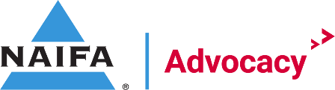

April National Grassroots Committee Meeting Agenda
4/9/2024
2:00pm to 3:00pm

Agenda

National Grassroots Chairman Welcome Josh O’Gara

IFAPAC Update Stephanie S.

Board Report Barbara P.

Federal Relationship Recap Holt
Federal Relationship Gaps for 118th Congress
Total percentage of US House & Senate districts with a relationship: 92%
Total number of US House Gaps: 50 = 89.5% Coverage
Total number of US Senate Gaps: 1 = 99% Coverage

State | Total Gaps | State | Total Gaps
California | 5 | Nevada | 1
Colorado | 4 | New Hampshire | 1
Florida | 2 | New York | 13
Georgia | 3 | Ohio | 1
Hawaii | 1 | Oregon | 2
Illinois | 3 | Pennsylvania | 3
Kansas | 1 | Tennessee | 0
Louisiana | 4 | Texas | 3
Maryland | 0 | Washington | 2
Missouri | 1 | Wyoming | 1

State Interactions Holt
- We are tracking all interactions in our new system to help your efforts on the ground when legislation moves, and we need to mobilize quickly.

Grassroots Training Course Josh O’Gara
- NAIFA FSA Academy Graduates to date
  - 532+ Graduates
  - If you need a list of chapter leaders in your state that have not completed the courses, please reach out to Gianna and she can get that over to you ASAP.
- NAIFA FSAA Live
  - April 24th at 2pm EST
  - https://members.naifa.org/fsa

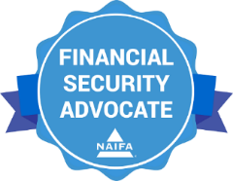

2024 Recognitions Josh O’Gara
  - 1st Quarter Hard Hat Nominees

Virtual Reception Series, Round 2 Holt
  - Last year, NAIFA Advocacy created a new way for our members to engage with their elected officials at the federal level. IFAPAC and Grassroots hosted 20 Virtual Receptions with lawmakers from across the country that sit on committees of jurisdiction. This unique series put our member front and center with their lawmakers, giving them an opportunity to ask different questions than we typically do while on Capitol Hill.
  - We are launching round 2, with 25 lawmakers across the country being selected. Please be on the lookout for invites to the meetings once they are set.

Candidate Selection Group Holt
- Next CSG meeting is April 16th
- Please submit any request for funds here: https://advocacy.naifa.org/candidate-request

Congressional Conference 2024 Holt
- https://conference.naifa.org/2024

Congressional Appointment Organizers Holt
- Webinar will take place on April 10th at 2pm EST
- States WITHOUT a nominated CAO
Western Region | HI, OR, WA, WY
Eastern Region | DC, MD, NH, VA
Central Region | LA, MN, OH

