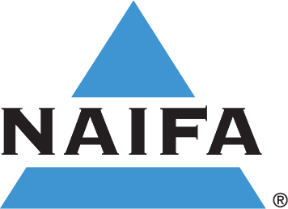

NAIFA – West Virginia

Invites You to Attend Live

Professional Insurance Continuing Education Webinar Events!

**2025 CE Class Schedule**

**Location: Webinar (Links and instructions will be provided prior to each class)**

Top of Form

Top of Form

Top of Form

 Thursday, Jan. 23, 2025 9:00 – 12:00 “Ethics and Your Insurance Career”  WV Course # 102726 – 3 CE hours

 Wednesday, Apr. 9, 2025 9:00 – 12:00 “Understanding Social Security”

WV Course # 102716 – 3 CE hours

 Wednesday, Sept. 10, 2025 9:00 – 12:00 “Understanding Medicare Advantage Plans”

WV Course # 109100 – 3 CE hours

 Wednesday, Dec 10, 2025 9:00 – 12:00 “Critical Illness and Disability Planning”

WV Course # 104424 – 3 CE hours

**Presented by: Insurance Career Training, Inc.**

**Cost: FREE**

Name

Street Address, City, State, Zip

Phone Insurance License #

E-mail Address

Agency

**RSVP by e-mail to John Pauley at** [**johnpauley@ft.newyorklife.com**](mailto:johnpauley@ft.newyorklife.com)

**or by phone to 304-345-4343 or by fax to 304-345-4342**

**or by mail to John Pauley, 1707 Clark Road, Charleston, WV 25314**

**NOTE: Regulations require you to log on and check in prior to class, answer each hourly roll call, and stay connected for the duration of the class to receive CE credit. ICT will file your CE credits with the state.**

**Certificates of completion will be e-mailed following class.**