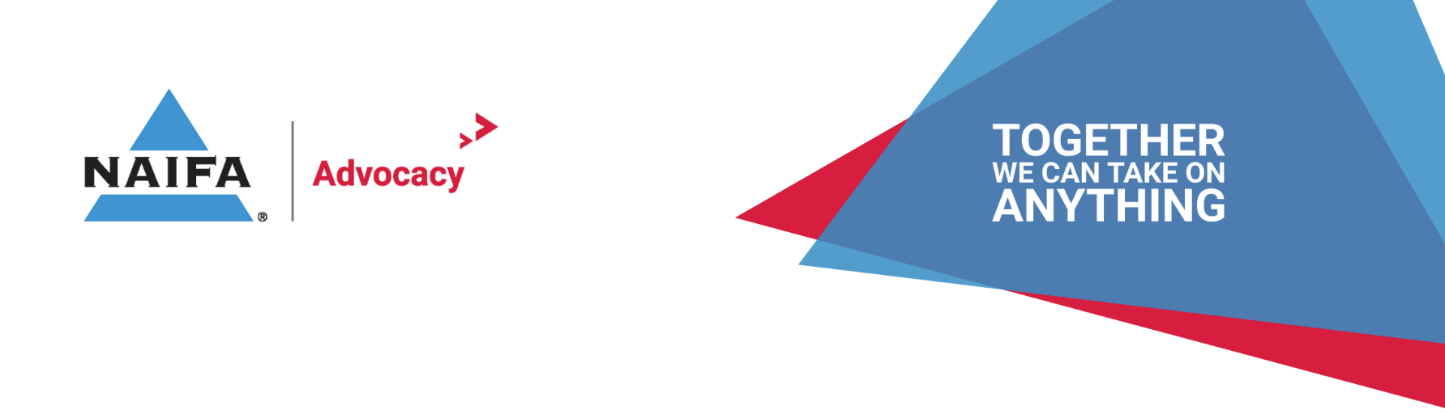
Financial Literacy Sample Comment Letter Template
By: NAIFA Government Relations, Updated July 2023

MONTH, DATE, 2023

NAME, (Representative/Senator)
ADDRESS
CITY, ST, ZIP
RE: FINANICAL LITERACY COURSEWORK FOR HIGH SCHOOL GRADUATION REQUIREMENTS
Dear REPRESENTATIVE/SENATOR NAME,
NAIFA-[STATE] (NAIFA-XX) and NAIFA would like to thank the HOUSE/SENATE XXXXX Committee for considering [BILL NUMBER] that would make a standalone financial literacy course part of high school graduation requirements in the state of [STATE NAME]. Our association & its members strongly support efforts by state governments to enhance access to financial education and recognizes the importance and value of financial literacy to future generations.
NAIFA members provide products, services, and guidance that increase financial literacy in our society. We protect clients against life's inherent risks, help hard-working Americans prepare for retirement, and create financial security and prosperity so their clients can leave a legacy for future generations. We serve individuals, families, and businesses in communities across the United States, building long-term relationships and often living and working in the same communities as their clients. We know firsthand that financial literacy is the foundation to achieve financial security. The NAIFA-XX Chapter has XXX members that serve our community.
In today's modernized world, more young people are exploring entrepreneurship, particularly with online businesses (social media, e-commerce, etc.), thus establishing a bigger need to begin financial literacy education at the high school level. According to a 2019 Experian Consumer Finance Survey, 76% of recent high school graduates said they wished their schools placed more emphasis on personal finance. Further, in 2021, 75% of teens reported wanting more personal finance education.
To date, 24 states have passed measures to implement a stand-alone mandatory financial literacy course in their high school curriculum to satisfy graduation requirements. NAIFA-XX is passionate about joining this group through the passage of [BILL NUMBER]. We appreciate your leadership in providing [STATE] students with a solid understanding of the basics of personal finance.

Sincerely,
Signature

NAME
NAIFA-State President

