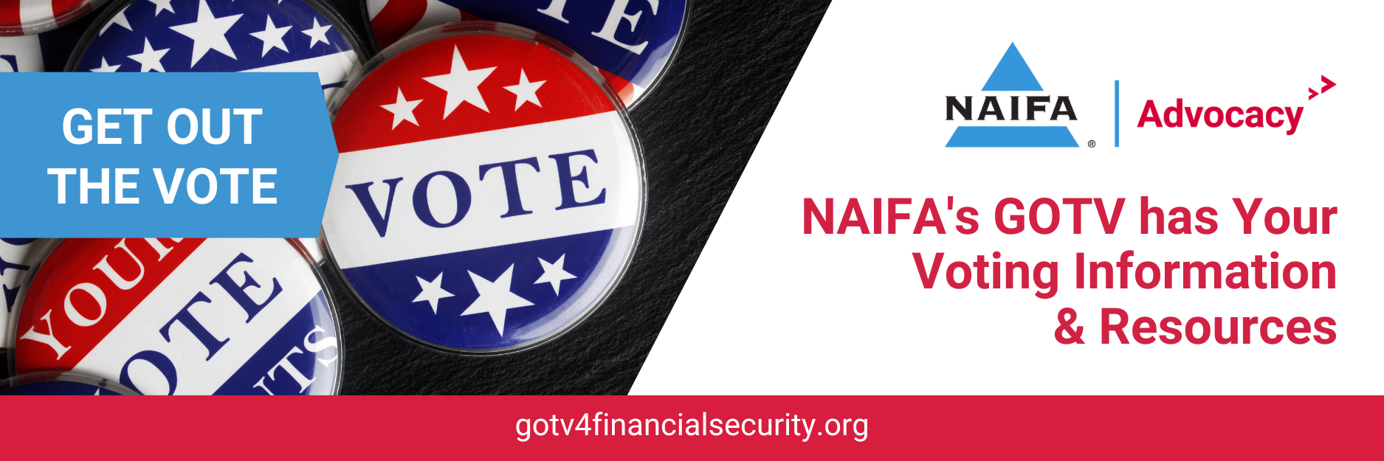
Sample Emails Insurance and Financial Advisors Can Send to Clients to Encourage Voting

Dear <client name>,

Are you registered to vote? More than 63 eligible Americans are not. Yet, participating in our democratic process – registering and voting – is another way we can protect our financial security. I’d like to share with you a resource page – gotv4financialsecurity.org – that makes it easy to:
- Register to vote
- Find your polling place
- Learn when upcoming elections are happening
- Learn about the voting process
- Research candidates running for office in your area

All of your financial planning can come to naught at the stroke of a pen if we don’t elect officials who make good policy decisions. Make sure you have a voice. Visit gotv4financialsecurity today!

Sincerely,

<your name and contact information>

Dear <client name>,

Do you have a child who recently turned 18? With the excitement of reaching this milestone age, our kids sometimes forget that on their 18th birthday they are now eligible to vote. It’s wonderful to see our kids become full participants in our democracy, but they have to be registered.

Voting is another way we can protect our financial security, and encouraging our children to become active citizens is part of helping them map out their future. Fortunately, getting registered and voting are easy. This resource page – gotv4financialsecurity.org – gives you and your new 18-year-old all the information you need to:
- Register to vote
- Find your polling place
- Learn when upcoming elections are happening
- Learn about the voting process
- Research candidates running for office in your area

Encourage your voting age children to visit gotv4financialsecurity today!

Sincerely,

<your name and contact information>

Dear <client name>,

As a financial professional, I see firsthand how decisions made by our government officials affect the financial security of Main Street Americans. Whether it’s saving for retirement, mitigating financial risks, leaving a legacy for our loved ones, or achieving any other financial goals we have set for ourselves, laws and regulations affect our ability to live the American Dream.

That’s why I encourage all of my clients – and everyone I know – to get registered and vote. The National Association of Insurance and Financial Advisors has created a great resource page – gotv4financialsecurity.org – that makes it easy to:
- Register to vote
- Find your polling place
- Learn when upcoming elections are happening
- Learn about the voting process
- Research candidates running for office in your area

Please take advantage of these tools and register to vote today!

Sincerely,

<your name and contact information>

