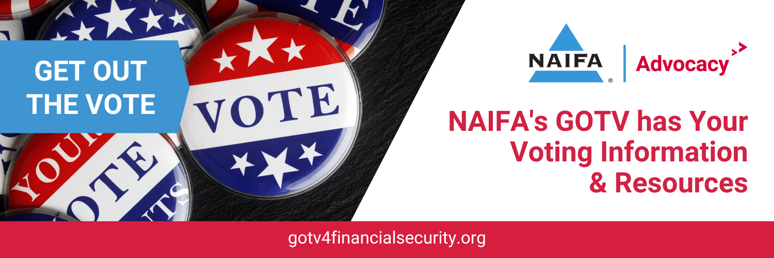
Voting Social Media Posts for Insurance and Financial Advisors

You’re preparing for retirement. You’re protecting your family with life insurance. What else can you do to look out for your financial security? Vote! Make sure you have a voice. Learn more at gotv4financialsecurity.org #voting #elections #employeesvote

Elected officials impact your financial security every day. So while you need insurance, you need a plan, and you need an advisor to help with your finances, you also need to vote. Learn more at gotv4financialsecurity.org #voting #elections #employeesvote

Are you one of the 63 million eligible Americans who is not registered to vote? You need to exercise your right to choose officials whose decisions impact your financial security. Learn more at gotv4financialsecurity.org #voting #elections #employeesvote

Did you or someone you know just turn 18? In order to vote you have to be registered. Learn more and get registered at gotv4financialsecurity.org #voting #elections #employeesvote

For September 19:
Today is National Voter Registration Day. Make sure you and everyone who’s eligible in your household is registered to vote. Learn more and get registered at gotv4financialsecurity.org #voting #elections #employeesvote

