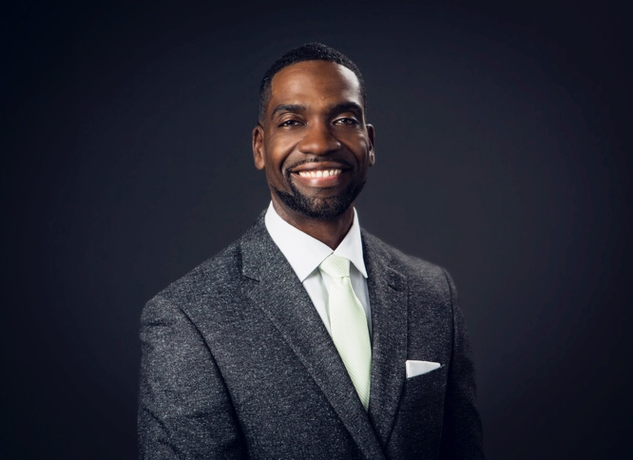



**Christopher “The Coach” Gandy, LACP**

**Christopher L. Gandy**

**Founder**

**Midwest Legacy Group, LLC**

**901 Warrenville Road suite #211, Lisle IL 60532**

**(312) 532-2257**

**cgandy@midwestlegacygroupllc.com**

Chris has spent the last 22 years helping individuals reach their most important financial goals. In 1999, Chris started his own financial services practice, and since then, has traveled the U.S. working with athletes, key executives and minorities. Chris specifically focuses on the areas of individual and corporate Life Insurance, Disability Income Insurance, Investments, Tax Reduction Strategies, Retirement Income Optimization and Pension Maximization.

Chris was a Communications major at the University of Illinois Champaign-Urbana. Outside of the classroom, he played on the Fighting Illini basketball team where he was co-captain and earned 2nd Team All Big-Ten honors. After college, Chris played basketball professionally for the Chicago Bulls, San Antonio Spurs, and in L’Hermaine and Vichy, France.

Early in his career, Chris worked as a Northwestern Mutual Financial Network Representative. While there, he received numerous awards and was a top producer. He became a Million Dollar Round Table (MDRT) Member in 2001 - the premier association of financial professionals. In the spring of 2005, Chris moved his financial services practice to the Molyneaux Financial Group, LLC, a general agency of Massachusetts Mutual Life Insurance Company, where he received the Impact Award in 2006 and Management Council and Leaders Conference Honors in 2007. This agency eventually became MassMutual Chicago.

In 2010 he started his own Agency, where he leads a team of highly skilled professionals, meanwhile still developing his clientele nationwide. He has been featured in numerous magazine articles; *Crain’s Chicago Business, GQ, Black Enterprise* and *African-American Career World, Insurance News and was recently featured on the cover of the National publication “Advisor Magazine.”*

In 2012 Chris found a way to give back to sports by becoming a member and sitting on the board of the Chicago Concussion Coalition whose goal is to make the game safer for children in amateur sports, founded by Chris Nowitski of the Emmy Nominated movie ***“Head Games”.*** Chris finds passion in helping resolve the issue of CTE in sports.

Chris donates his time and efforts to many organizations. He serves on the Board of Directors for the Urban League, Naperville’s ALIVE youth center, IAMABEL foundation and is also part of the United Way’s Young Community Leaders. He volunteers for the Big Brothers/Big Sisters organization and YMCA; he spent four years on the board of the SAME Network of Chicago’s RUSH Medical Center focused on diversity and integration with a S.T.E.M. focus for minority medical students.

In 2013 Chris was nominated to the National Basketball Retired Players Association (NBARPA) Chicago chapter and served as a Board member; while again qualifying for the Court of the Table of Million Dollar Round Table. He is now considered a Lifetime member of the highly esteemed MDRT.

Chris is a lifelong advocate of diversity and inclusion. He served as President for the Board of Directors for NAIFA Chicagoland (***National Association of Insurance and Financial Advisors***) & serves on NAIFA’S groundbreaking national committee, the ***Diversity and Inclusion Task Force.*** He was recently nominated as a National Trustee on the National Board of NAIFA. He travels nationally, speaking on the impact of equity and inclusion to diversity groups such as ***NMA, SNMA, LMSA, CCPA, GAMA, LAMP, ITKAN, MDRT,*** and ***NAIFA.***

In 2020 Chris was awarded NAIFA’s prestigious Impact Award and was appointed by NAIFA’S National President -Tom Michael to serve as a national trustee for the industry’s largest association for insurances professionals focused on advocacy and education.

Chris is dedicated to helping individuals develop personalized financial strategies and goals. Chris lives in the western Chicago suburbs with his son, Jordan, an NCAA Student-Athlete and the starting Quarterback for the Northern Illinois University Huskies. Chris is a Registered Representative who works on your behalf to present ***you,*** the client, with major insurance carriers and investment providers in the marketplace, to help find quality strategies and products.

Call or email Chris today to find out how he can help you build and execute your life-long financial game strategy.

***“Diversity is the strength of perspective”***

* Christopher L. Gandy is a registered representative of and offers securities through MML Investors Services, Inc. 312-984-1000.

* Christopher L. Gandy is a registered representative of and offers securities through MML Investors Services, Inc. 312-984-1000.