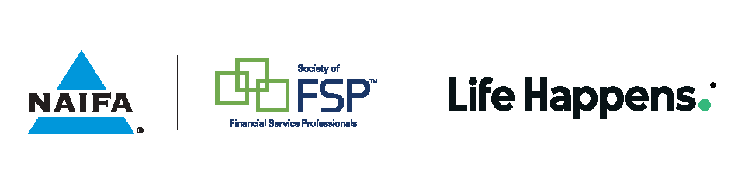

Member Profile Form
Help us spotlight you in an upcoming Advisor Today blog post. Simply complete this form and email it along with a current headshot to membernews@naifa.org.

Full Name (as you’d like it to appear):
Loyal Member Since:
Home City & State:
Name of firm/agency/company:

How did you get into the business?

What about this industry attracted you to start down this career path?

How did you come to find NAIFA? Why did you decide to join?

What do you enjoy about your career in the financial services industry? What keeps you motivated?

What area do you specialize in or would like to one day specialize in?

How important is NAIFA’s political advocacy to the success of your business and/or your clients?

Is there a specific advocacy issue at either the state or federal level that has had a direct impact, or threatened to have a direct impact, on your business?

NAIFA encourages members’ political engagement and advocacy to promote their own business success and on behalf of their colleagues and consumers as part of being a “good NAIFA citizen.” Have you been politically involved? And if so, how?

Why is NAIFA important to you and how has it contributed to your success?

Why would you recommend this career to someone?

Why would you recommend NAIFA to someone?

Is there anything you would like to add about yourself, your career and/or NAIFA?

